**Android Internship Report**

**Personal Details**

Name : Shah Yash Harihar

College Name : Dharmsinh Desai University

Degree : B.Tech.

Semester : 7

GitHub URL : <https://github.com/syash2581>

Repo Name : 15DaysTrainingAtAP

**Company Details**

Company Name : Akash Technolabs

External Guide : Akash Padhiyar

Training Duration : 26-05-2021 to 21-06-2021

**Index**

|  |  |  |
| --- | --- | --- |
| **Index** | **Task Detail** | **Page Name** |
| 1 | Introduction to Android | 1 |
| 2 | Hello world application | 2 |
| 3 | Making a small application using UI controls and Use of Toast | 3 |
| 4 | Basic Calc (Addition and Subtraction) | 4 |
| 5 | Use of Explicit and implicit Intent | 7 |
| 6 | How to make splash screen | 10 |
| 7 | List View, Array Adapter (List.setAdapter), Grid View, Vertical and Horizontal ScrollBar | 13 |
| 8 | Custom List View and Grid View | 17 |
| 9 | SharedPreferences - getSharedPreferences and Editor | 21 |
| 10 | Making a call, Sending a mail, Sending a sms, Playing an audio using MediaPlayer, Playing a video using VideoView and MediaController | 25 |
| 11 | Android Application Project | 32 |

# **1 – Introduction to the android.**

* Evolution of android technology.
* Current value of android technology in market
* Ways to create applications.
* Ways to host those applications.
* What we are going to cover in these 15 days training.

# **2 – Hello world Application**

* Starting with android studio and SDK installation
* Introduction to AVD Manager in order to use virtual device for applications
* Creating your first android app
* Running it on to the simulator

Code

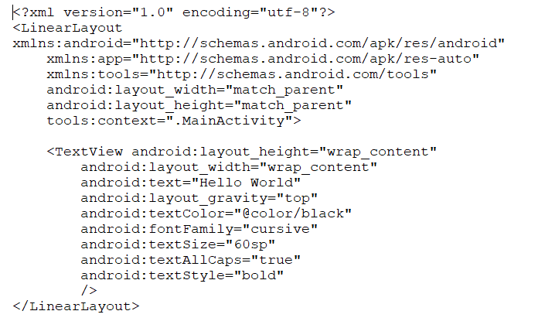

Output



# **3 - Making a small application using UI controls and Use of Toast**

Code

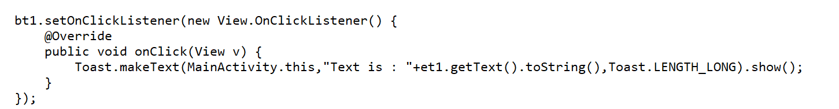

Output

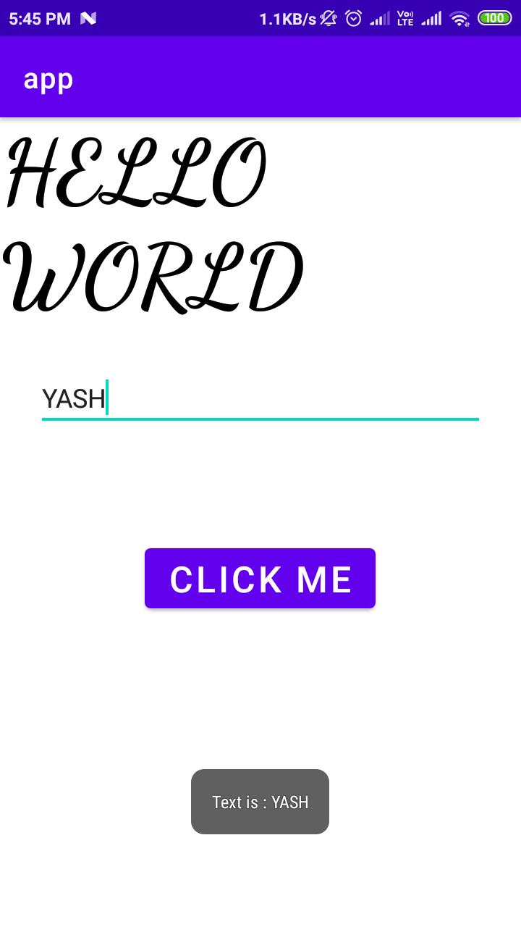

# **4 - Basic Calc (Addition and Subtraction)**

Code

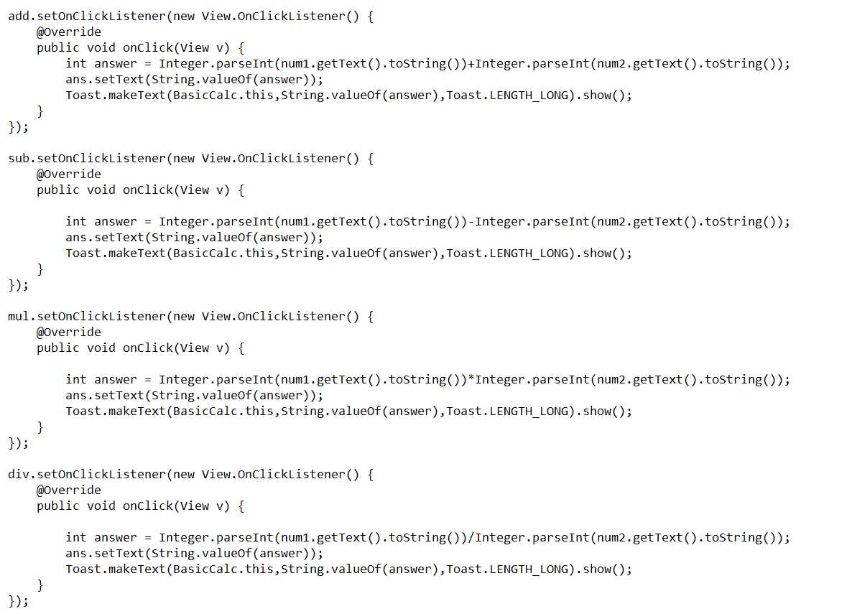

Output

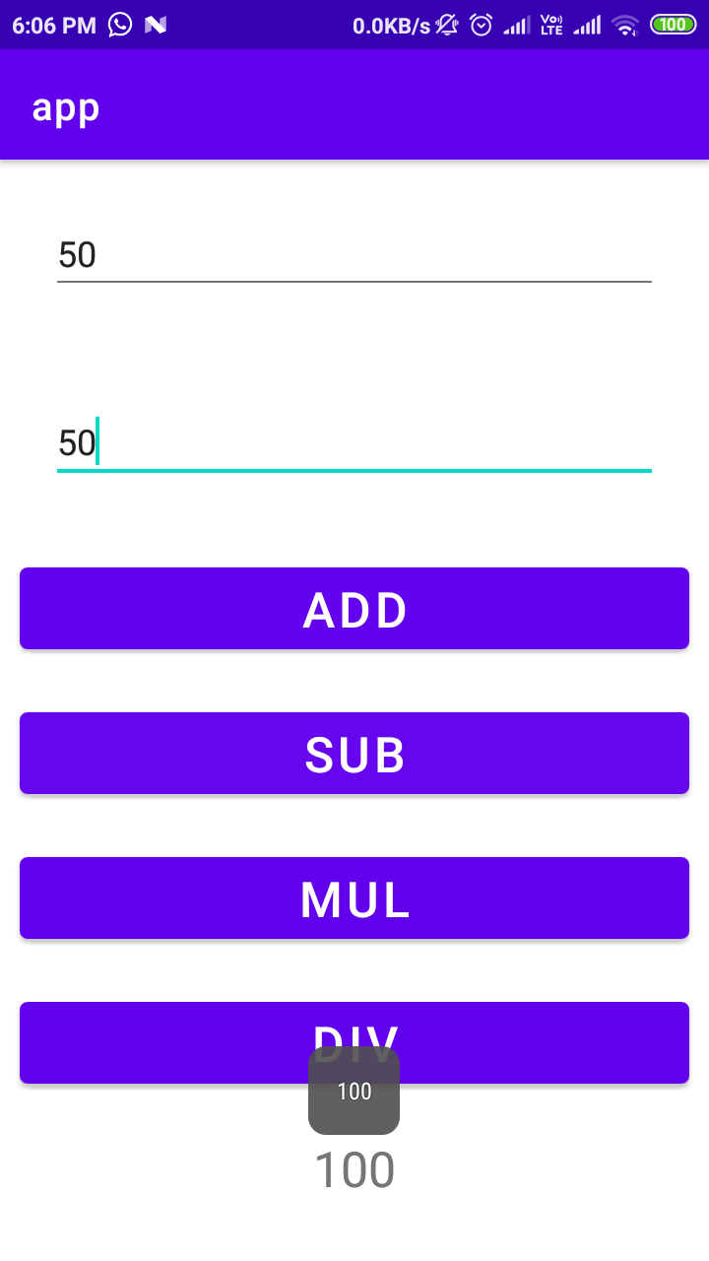 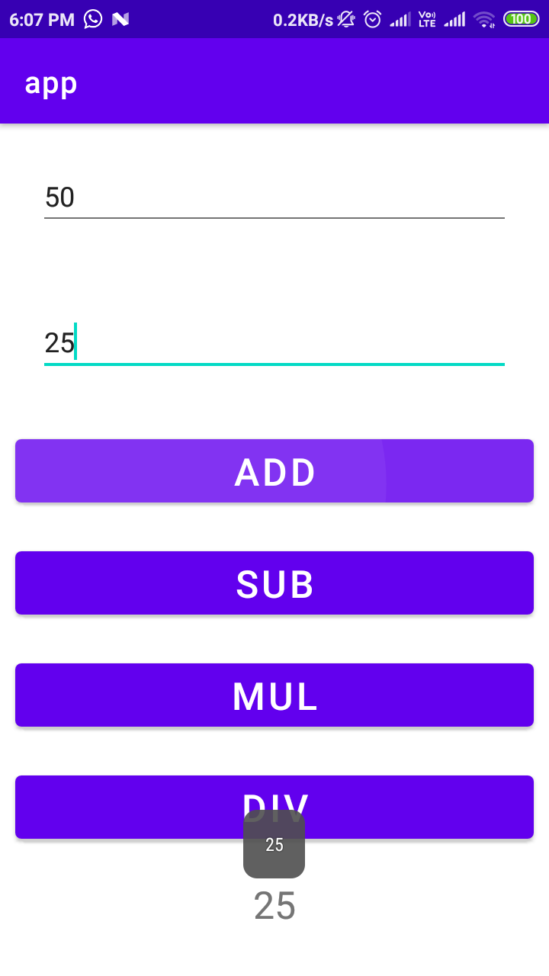

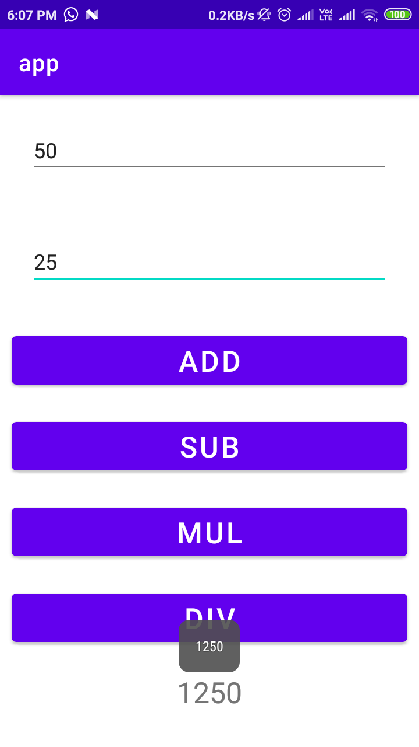 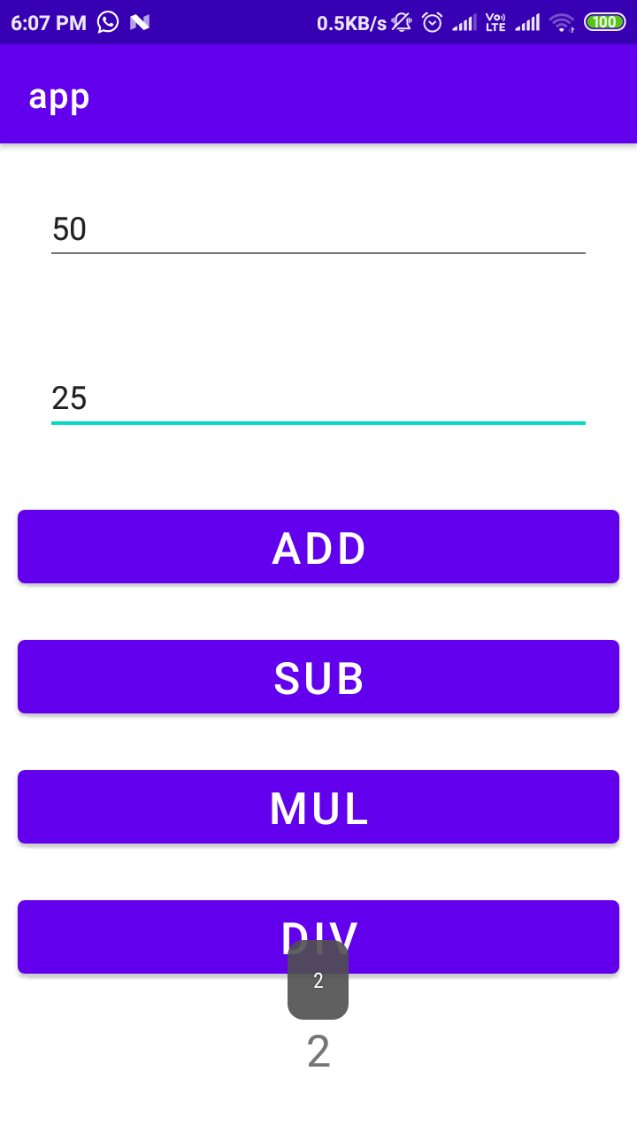

# **5 - Use of Explicit and implicit Intent**

Code

ImplicitIntent.java

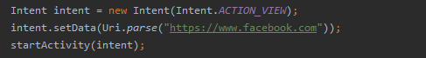

MainActivity1.java

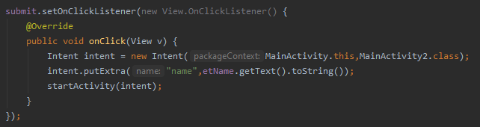

MainActivity2.java

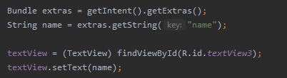

* putExtra() method is used to put additional information in intent.
* On the other hand, in second screen, getExtras() is used to get the extra information which are stored in MainActivity.
* Nevertheless, after getting intent we can use getStringExtra() directly to the intent object.

Output

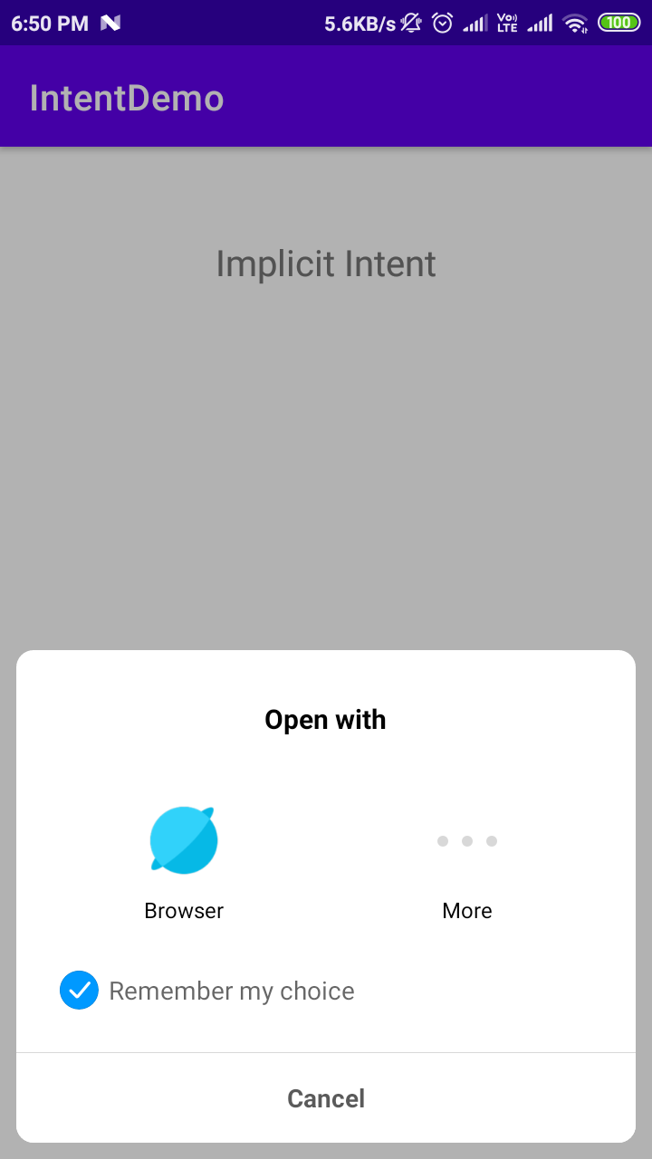 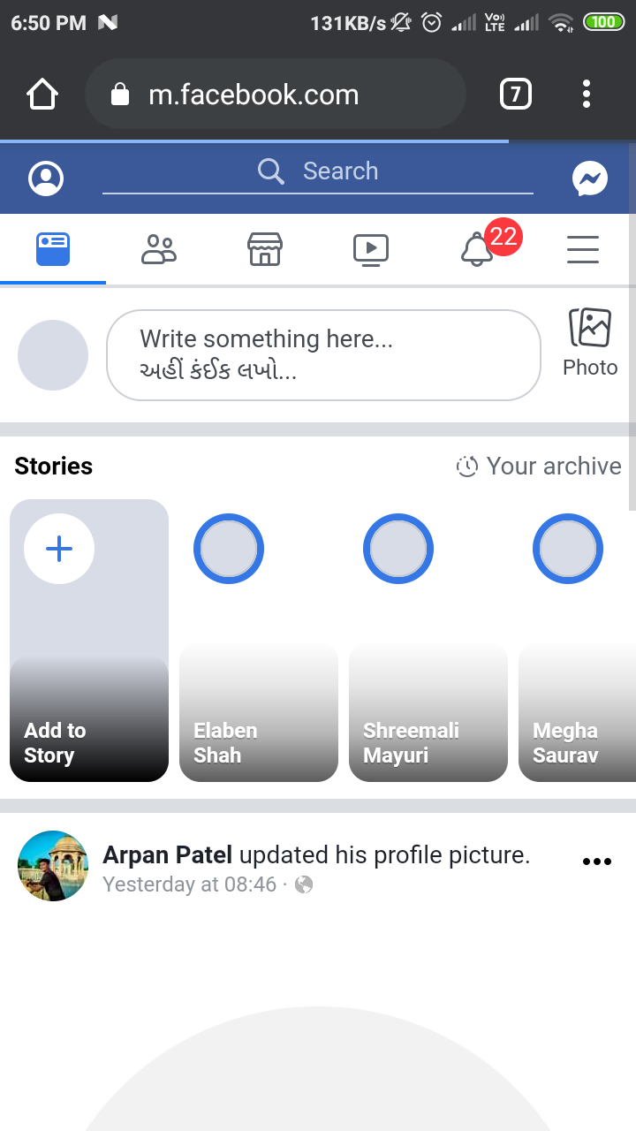

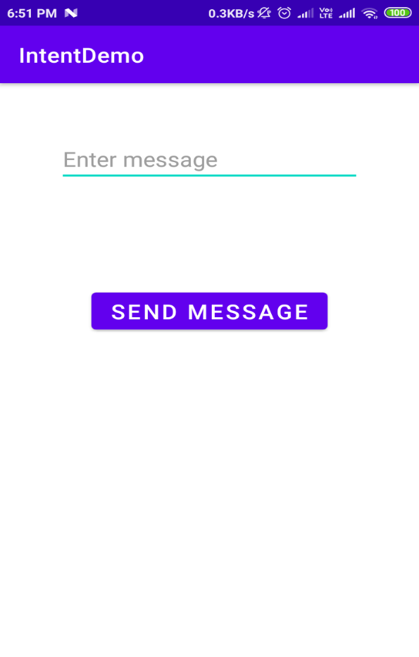 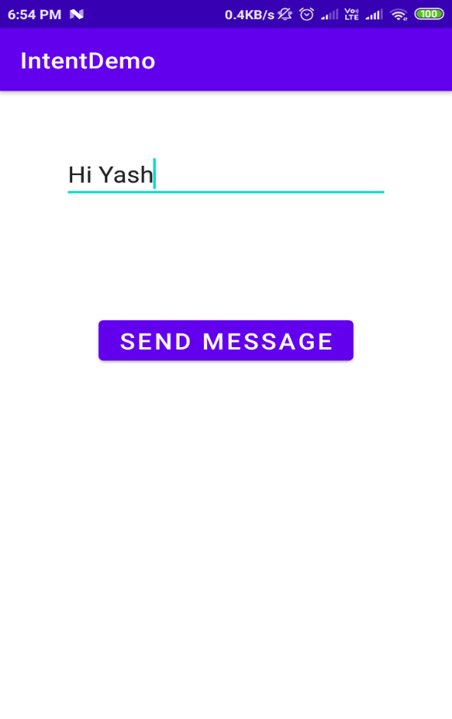

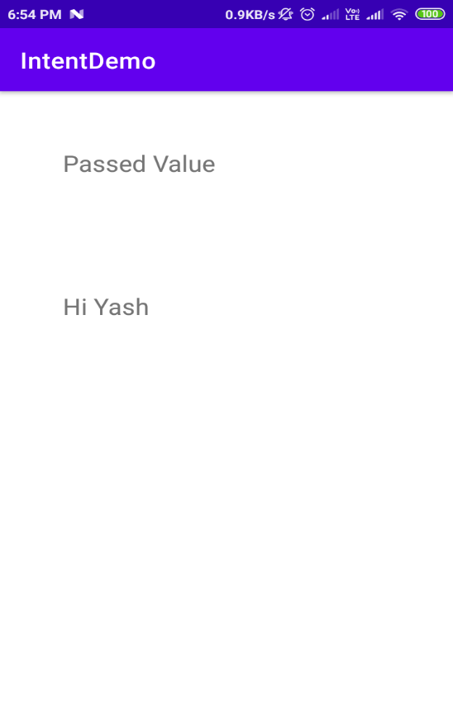

# **6 - How to make splash screen**

Code

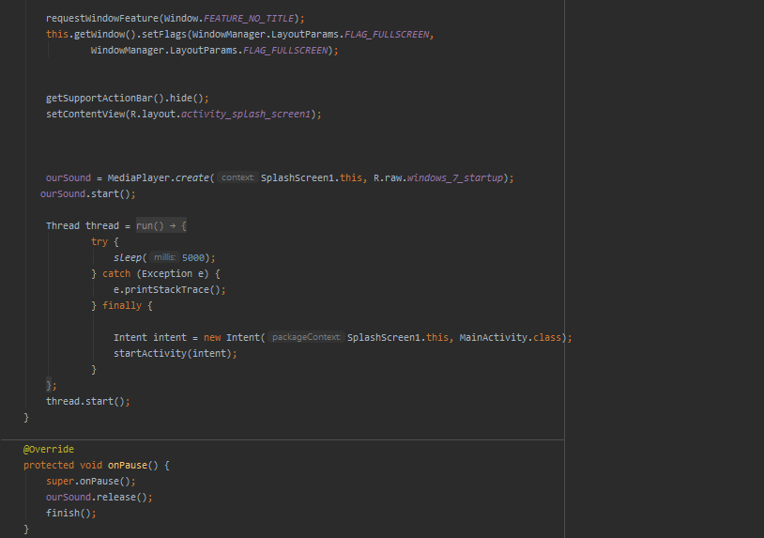

* Using mediaplayer.create() to create an object
* Object.start() = to start music
* And in onPause method object.release() = to release the resources.
* Also finish() is called because we don’t want our splash screen to appear again and again in a same session.

Output

 



# **7 – Web View, List View, Grid View, Vertical and Horizontal Scrollbar**

Code

WebViewDemo.java

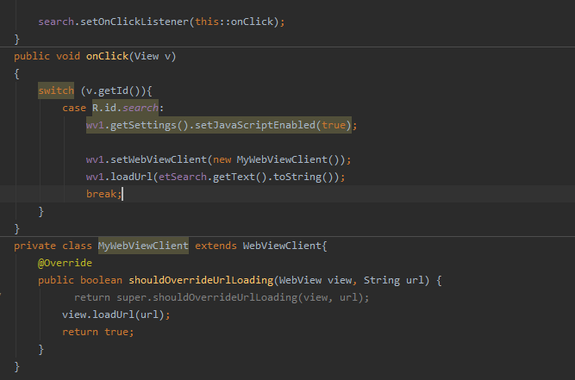

* Creating general listener and then distinguish them using switch-case.
* Extending WebViewClient to open all pages of website in your app not opening it in browser.
* You have to just load url (view.loadUrl(url)) and return true;

Output

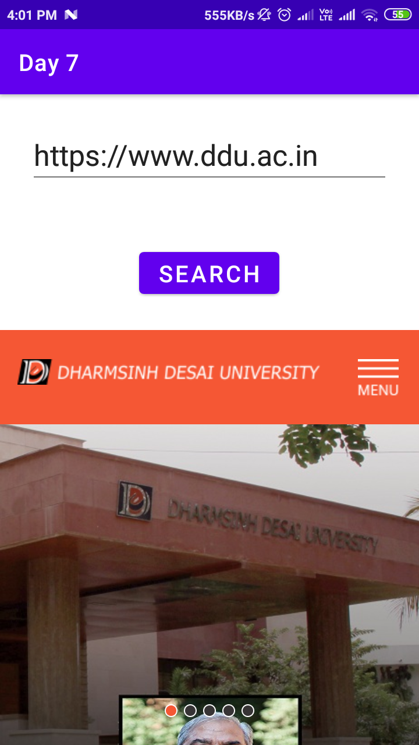 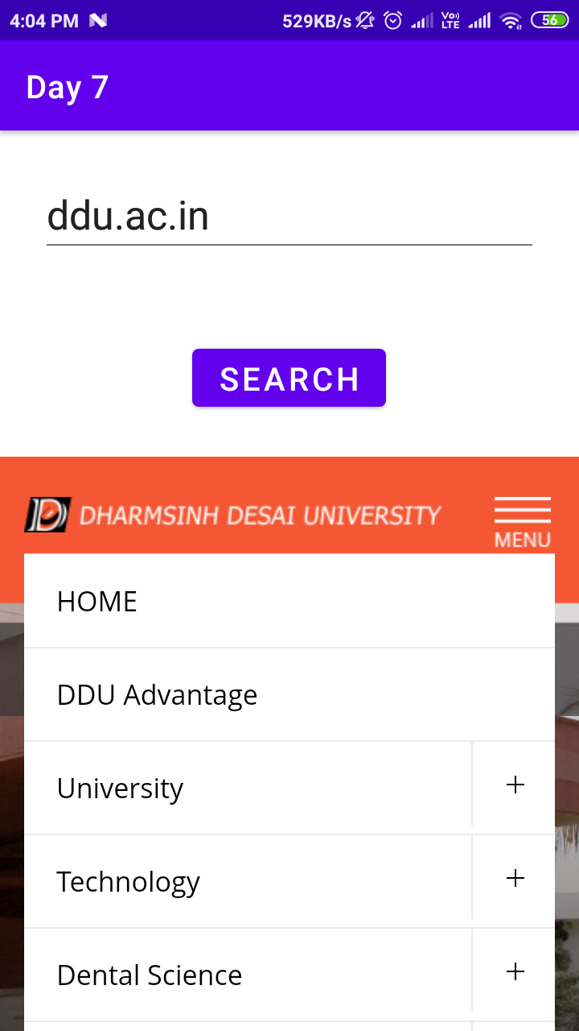

Code

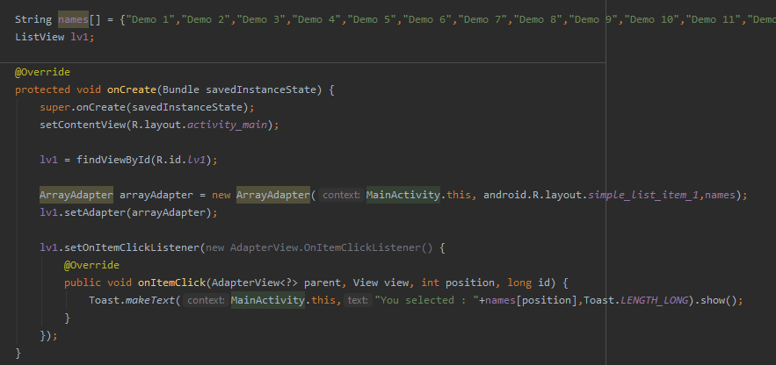

* Requires the data in form of array
* Requires ArrayAdapter which works as a bridge between Screen List UI and array.
* Override setOnItemClickListener() method to handle click event on listview.

Output

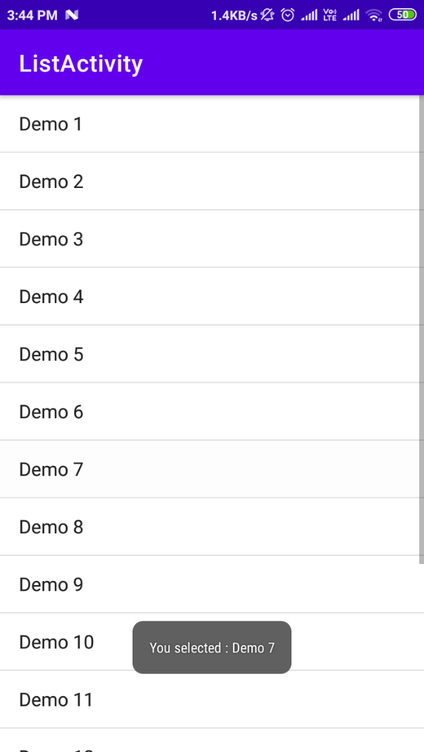 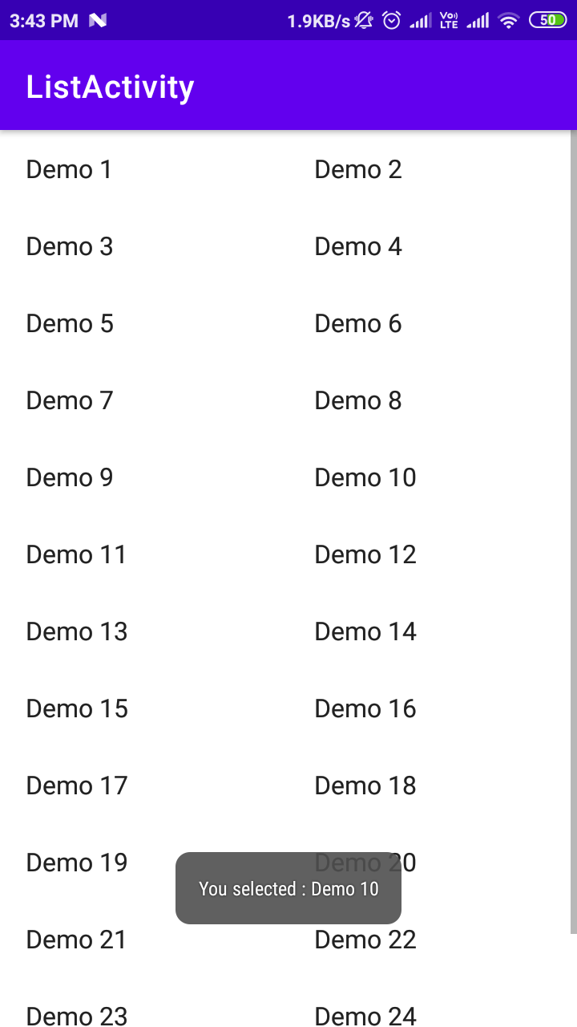

# **8 - Custom List View and Grid View**

Code

MyAdapter.java

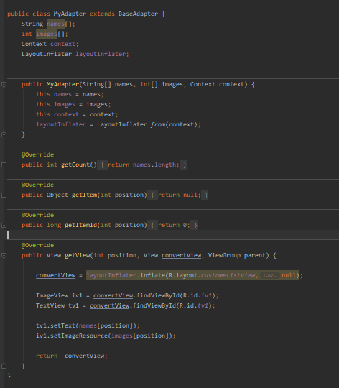

* For custom listview you need to create separate class which extends BaseAdapter class and override its abstract methods.
* getView in which you have to return a view that makes a single item.
* Mainly override getCount() and getView() method.
* You can get access to layout UI using LayoutInflator.

MainActivity.java

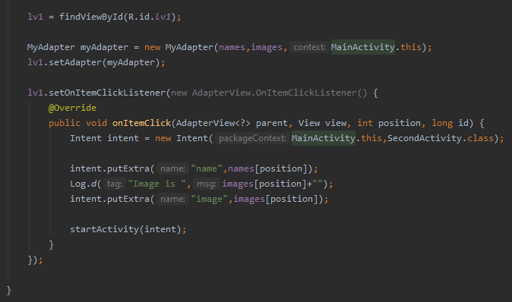

* Create an object of MyAdapter
* Pass string array names and int array images and context.
* Set the adapter (lv1.setAdapter(myAdapter))
* Finally, implement setOnItemClickListener().
* In which create an intent and put extra information like- name and image id  
  form array using position.

Output

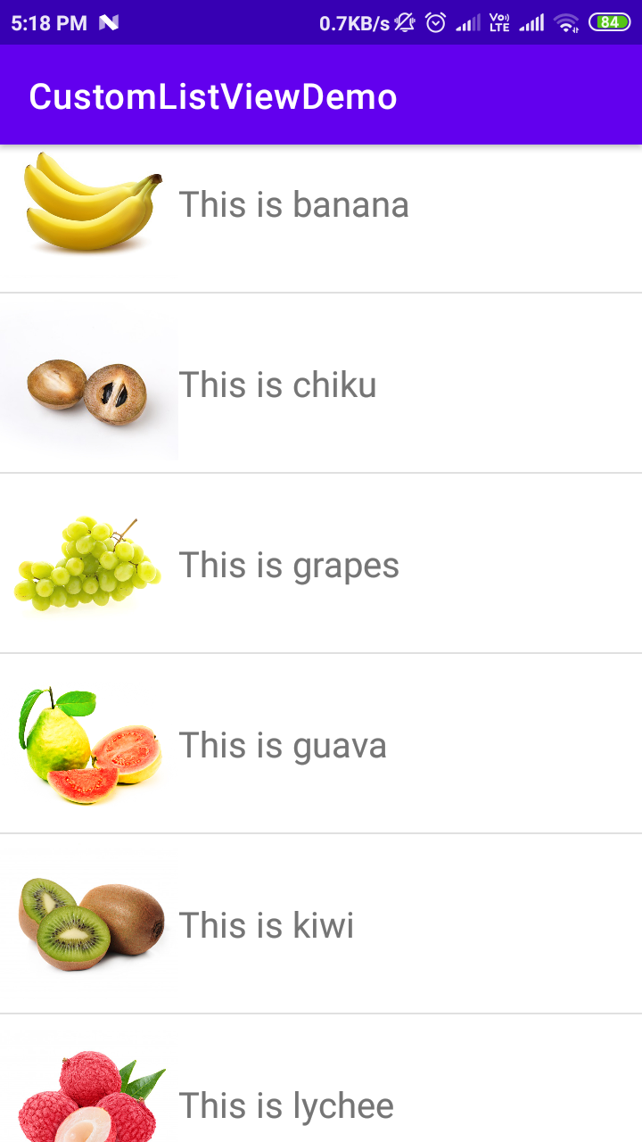 

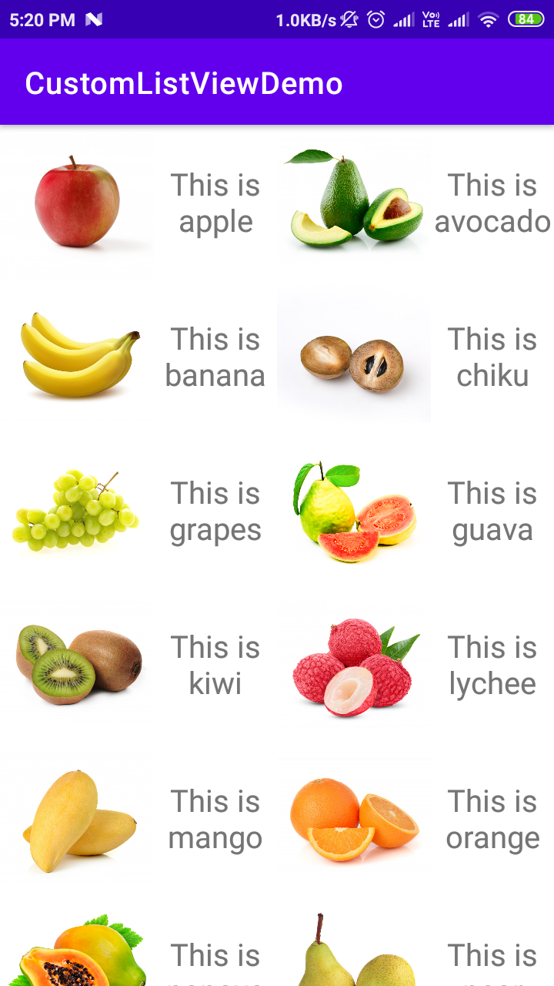 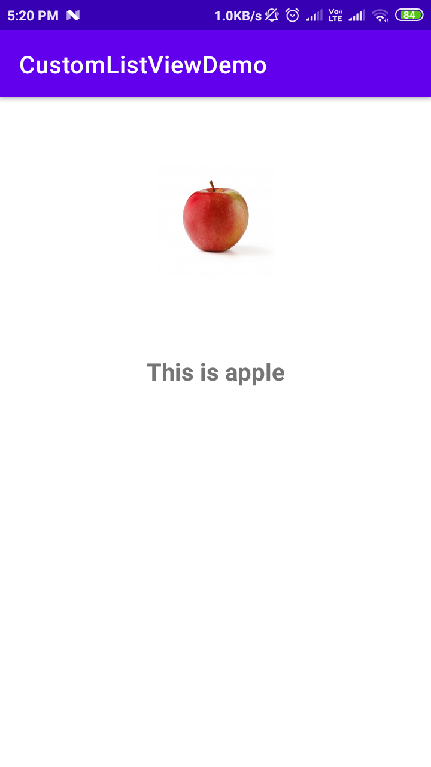

# **9 - SharedPreferences - getSharedPreferences and Editor**

Code

SignUp.java

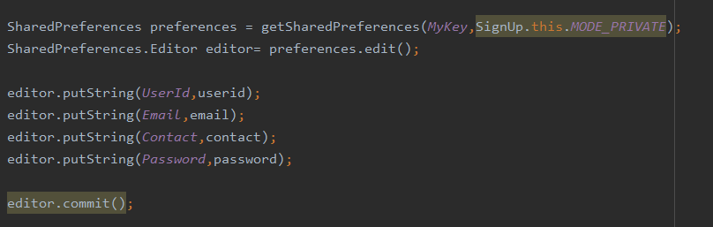

* First grab the SharedPreference object using getSharedPreferences passing the argument key name and mode.
* Then if you want to add or delete values from it you need to use editor which is sub class of sharedpreference.
* SharedPreferences.Editor editor = preference.edit() = edit() method will give you an object of Editor class
* Then using putString method you can put various values in it.
* Finally, you have to call editor.commit() method to save changes.

Login.java

* Here also you need to grab the object first.
* But here you do not need Editor class’s object unless you want to add anything
* For reading values from SharedPreferences only object of SharedPreference is sufficient.
* For that you need to use getString(key,defValue) method of SharedPreference.

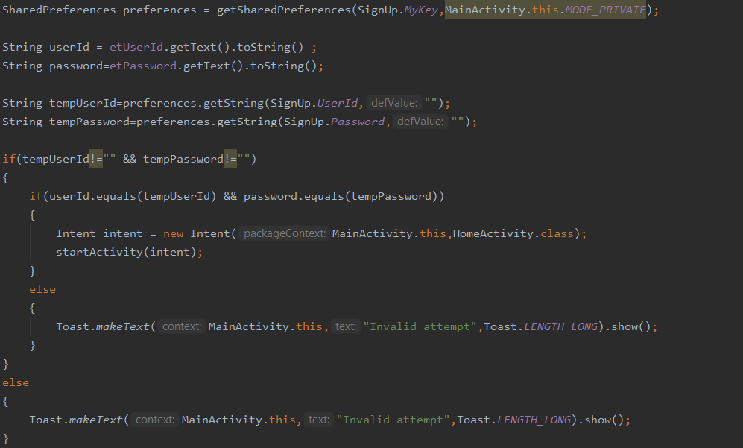

HomeScreen.java

Logout Functionality

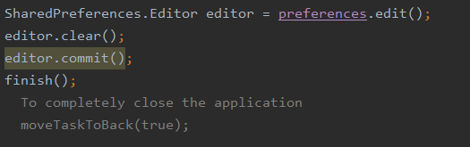

* Again, if you want to remove sharedPreference. You need to use Editor’s object.
* Simply calling editor.clear() will clear the values but don’t forget to call **commit()** method otherwise **impact will not be done**.
* To remove entire application you may use moveTaskToBack(true).

Output

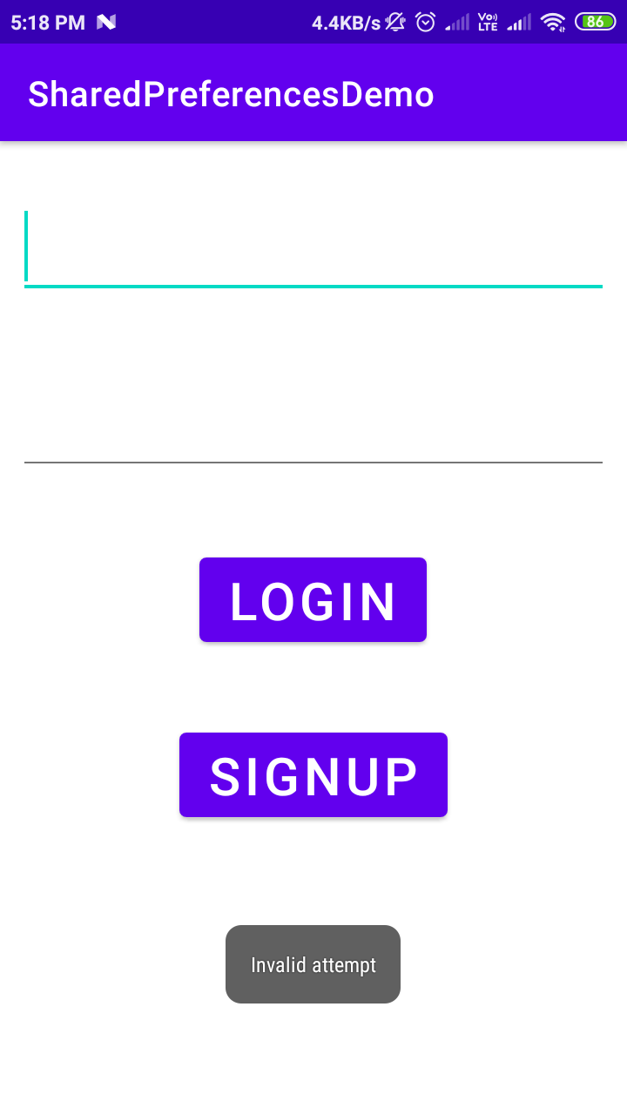 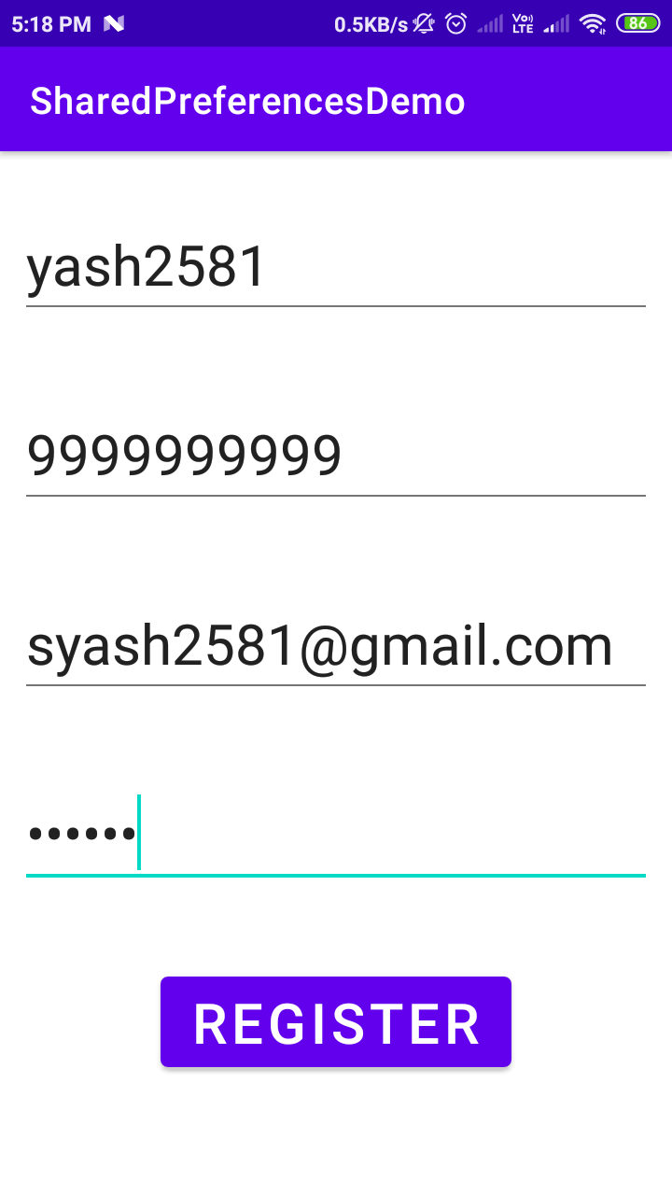

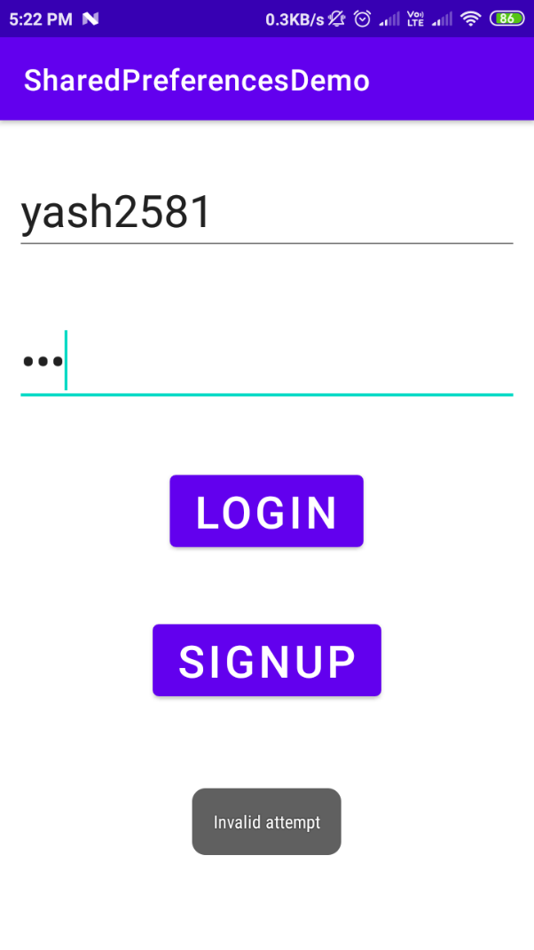 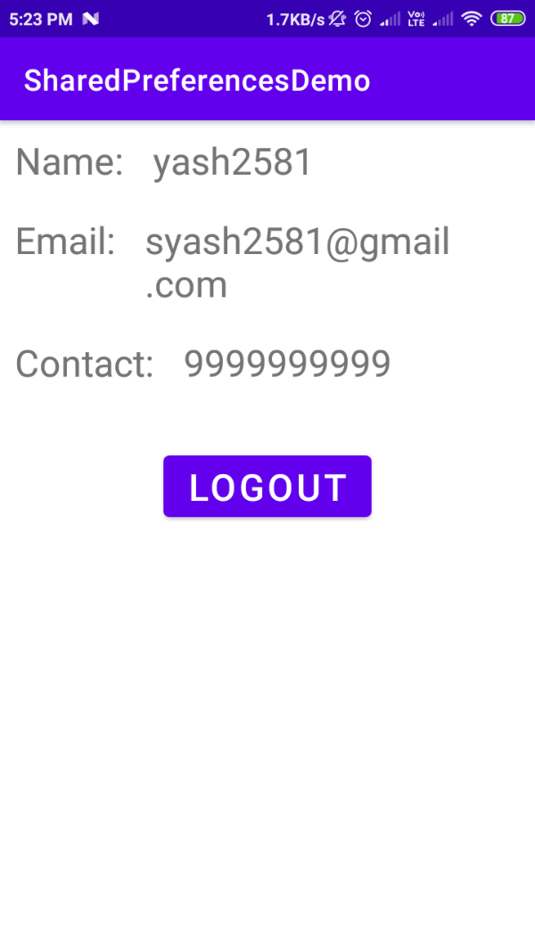

# **10 - Making a call, sending a mail, sending a sms, playing an audio using MediaPlayer, playing a video using VideoView and MediaController**

Code

CallActivity.java

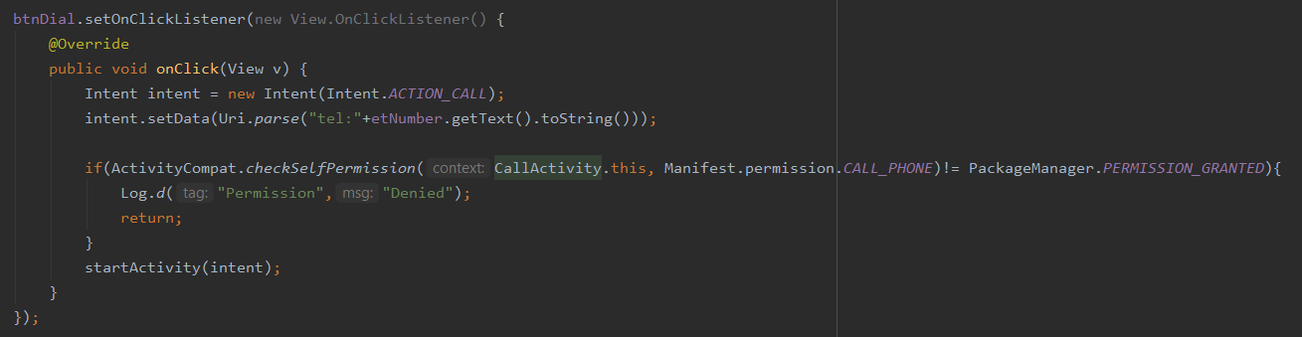

* Create an intent of type ***ACTION_CALL*** then set <tel:+number> as data in setData method.
* Check for telephone permission
* If granted then start the activity else show the message.

Output

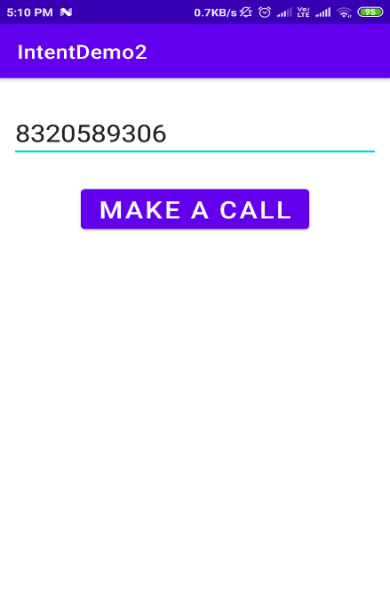 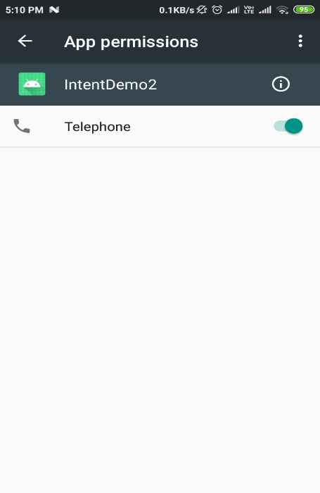

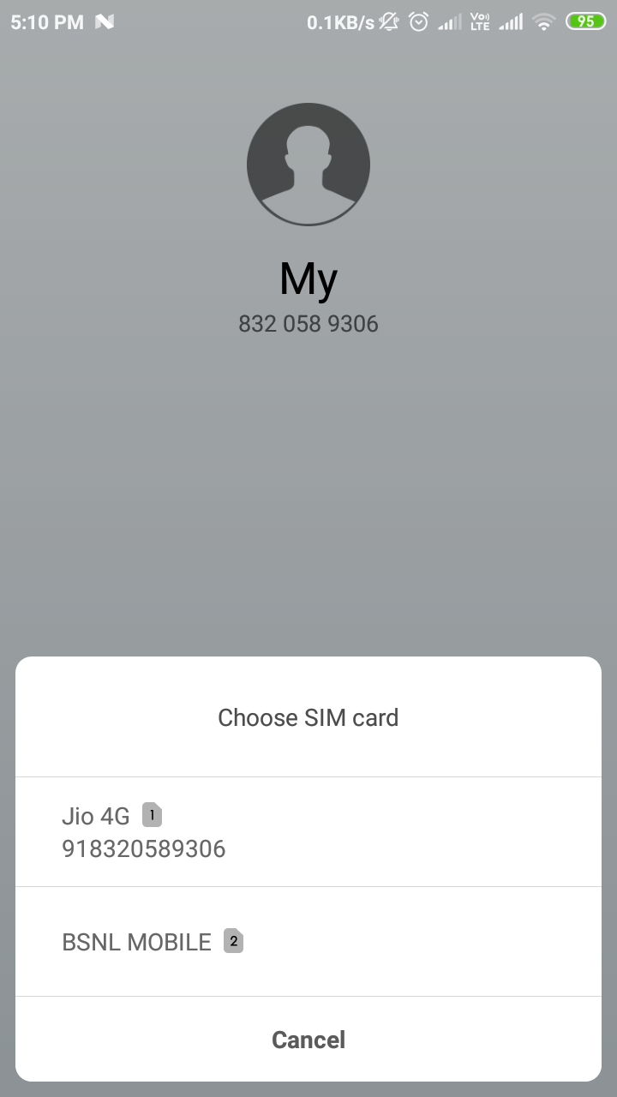

Code

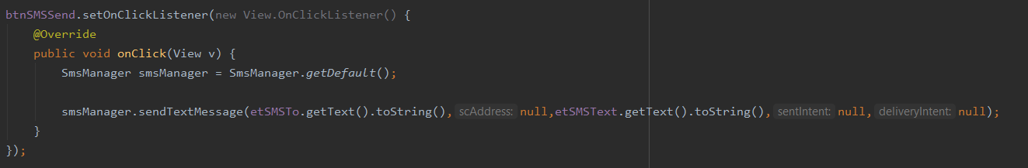

* Using smsManager API to send a sms.
* Get the object and use sendTextMessage and it’s done.

Output

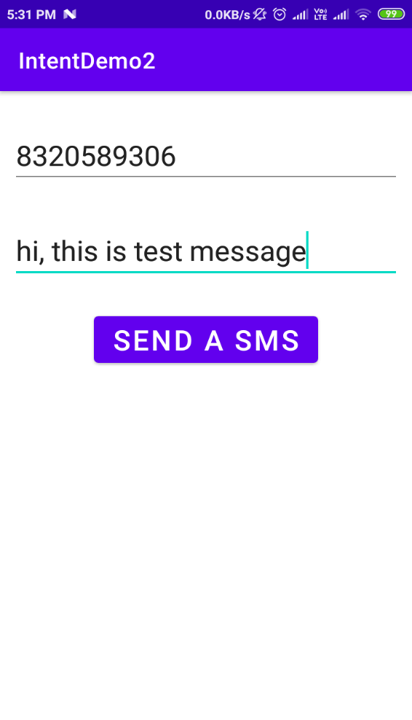 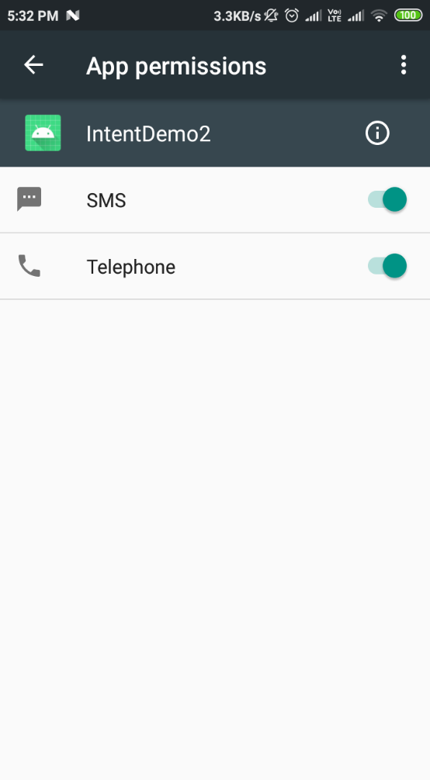

Code

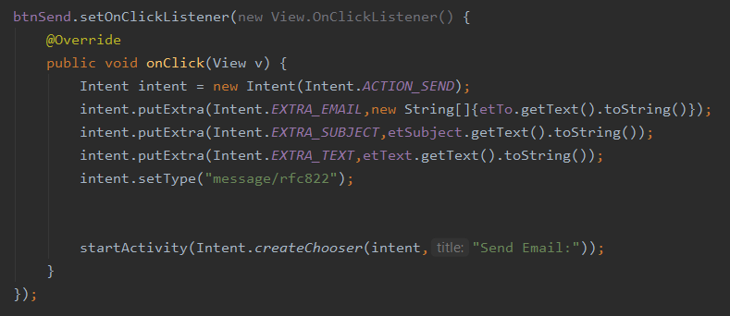

* Use Intent.ACTION_SEND
* Then add basic four fields
  + Intent.EXTRA_EMAIL, new String[]{array values}
  + Intent.EXTRA_SUBJECT, add subject as string
  + Intent.EXTRA_TEXT, add message as string
  + Specifying email type => setType(“message/rfc822”);
* Start the Activity and you can use Intent.createChooser(intent,”Send Email:”)) method to give options to user to send email like- gmail , phone’s inbuilt main app.

Output

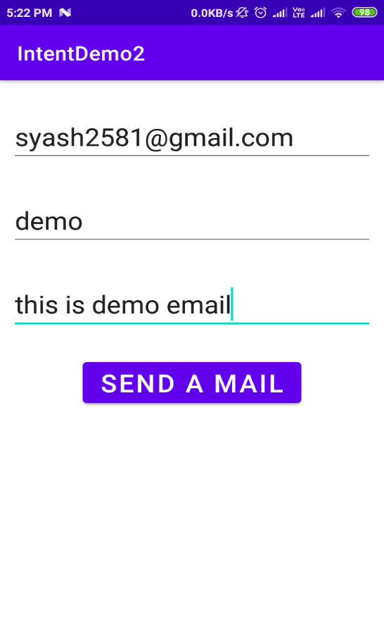 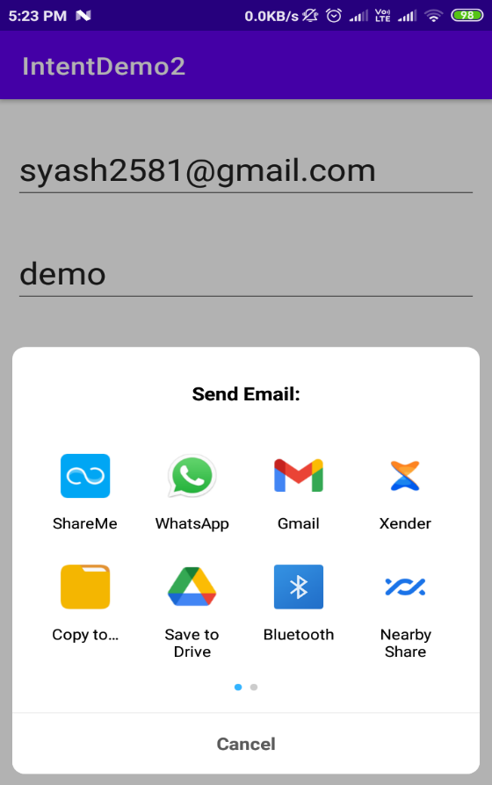

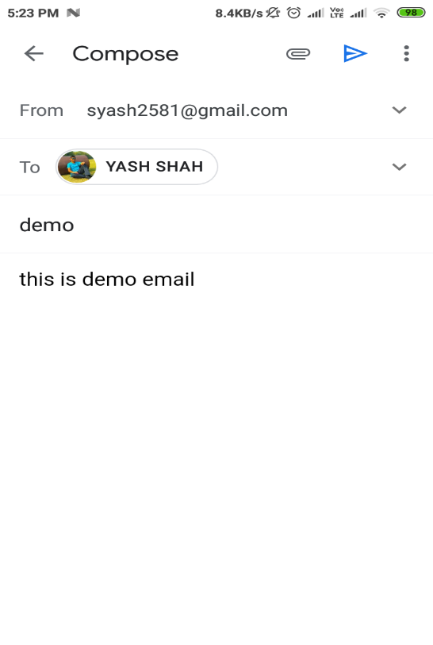

Code

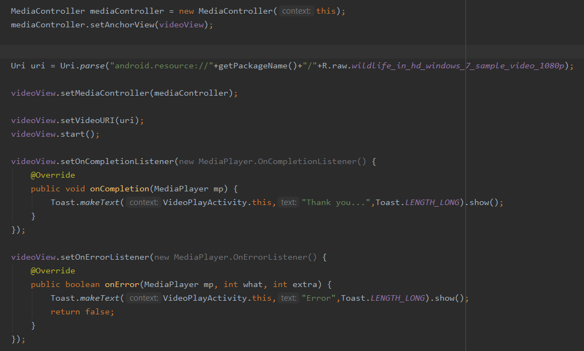

* Create mediaController for video
* And use setAnchorView(videoView)
* Use uri to create argument for videoView
* Use setVideoURI(uri)
* VIdeoView.start()
* Add listeners setOnCompletionListener and setOnErrorListener.

Output

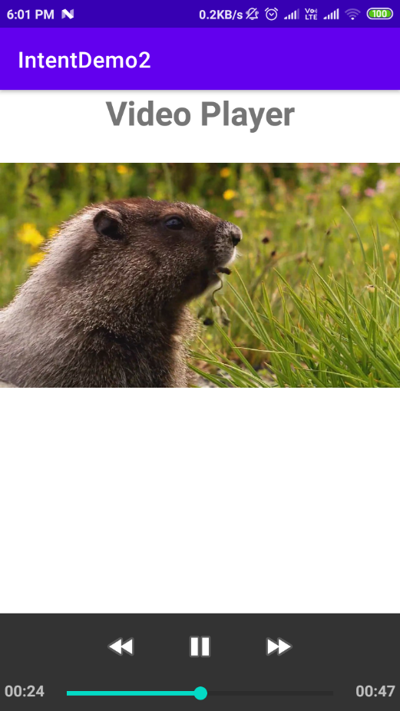

# **11 – Android Application Project**

* Developed Bhakti Application using Flutter.
* Nowadays, everyone wants that there morning should be energetic and for that they pray god and for that they require bhajans.
* Now if they use youtube then they have to turn the screen on while playing the song and it cause battery drain.
* Secondly, it they download apps like gaana , savan then they have to deal with advertisement coming between songs.
* And finally, both ways require high speed internet.
* My application has resolved all this issues just providing offline songs through application not only that but it does not use internet any way.
* Link: <https://www.tinyurl.com/BhaktiApplication>
* Snapshots

